Online Shopping Application - Project Report

Abstract
This project is an Online Shopping Application developed as part of the Capstone Project. The system provides a user-friendly platform for customers to browse products, add items to the cart, place orders, and track purchases. Administrators can manage products, categories, and user accounts. The backend is implemented using Spring Boot with REST APIs and MySQL as the database. The frontend is developed using React.js with Bootstrap for UI components. Authentication and authorization are handled using Spring Security with JWT. The project ensures scalability, security, and usability, adhering to modern e-commerce standards.

Tech Stack & Architecture
- Frontend: React.js (with Bootstrap)
- Backend: Spring Boot (REST APIs)
- Database: MySQL
- Authentication: Spring Security with JWT (JSON Web Token)
- Build Tools: Maven (backend), npm (frontend)
- Deployment: Localhost / Docker
Architecture Flow:
[React Frontend] → [Spring Boot REST API] → [MySQL Database]

Key Features
- User Authentication (Login & Registration with JWT)
- Product Browsing, Search, and Filtering
- Product Details View
- Shopping Cart Management
- Order Placement and Order History Tracking
- Checkout with Dummy Payment Integration
- Admin Dashboard for Product, User, and Order Management
- Swagger API Documentation for backend endpoints
- Backend execution in Spring Boot IDE

User Module
Handles user registration, login (JWT authentication), profile management, and role-based access (Customer/Admin).

Product Module
Allows customers to browse products by category/brand, search, filter, and view details. Admin can perform CRUD operations on products.

Cart Module
Enables customers to add/remove products to cart, update quantities, and view cart total.

Order Module
Supports order placement, order confirmation, order history for customers, and order management for admin.

Payment Module
Integrates a dummy payment gateway for secure checkout (e.g., Razorpay/Stripe sandbox).

Admin Dashboard
Provides admin functionalities like managing products, categories, users, orders, and viewing sales reports.

Screenshots
Login Page
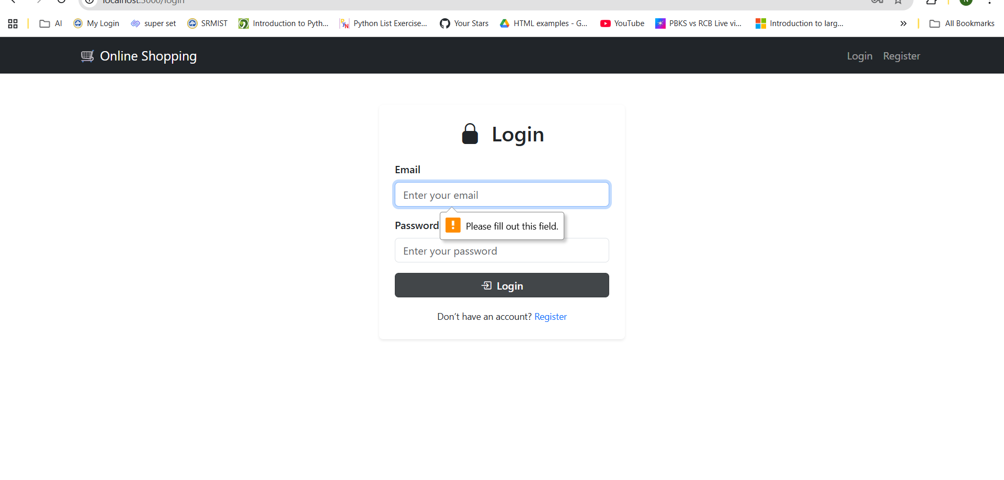
Home Page - Featured Products
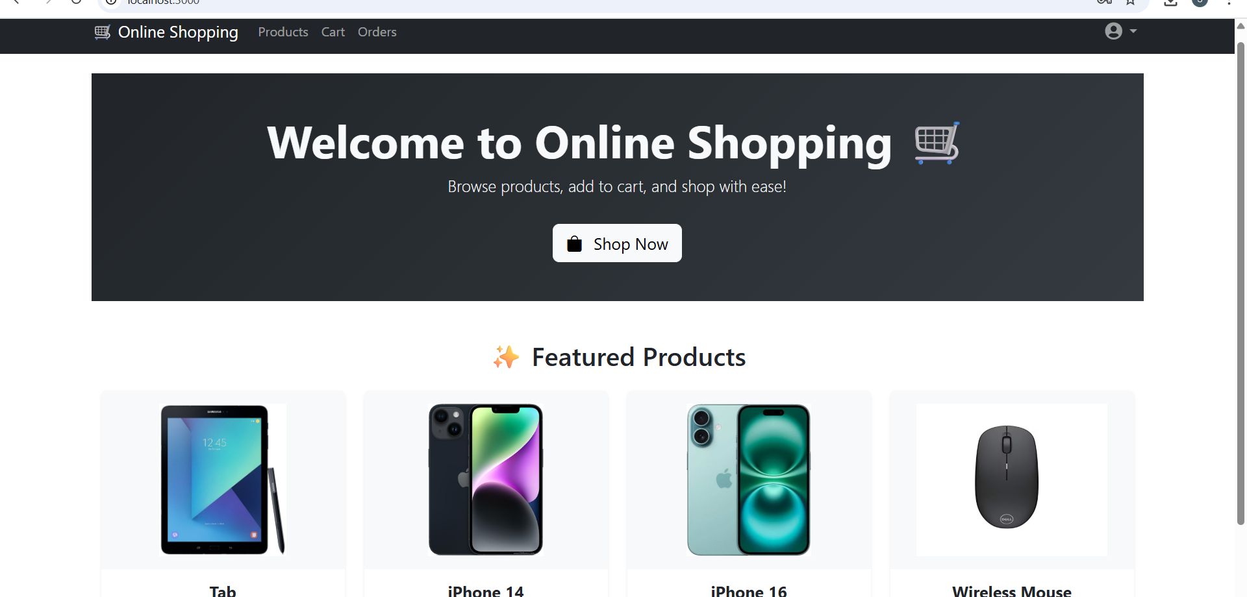
All Products Page
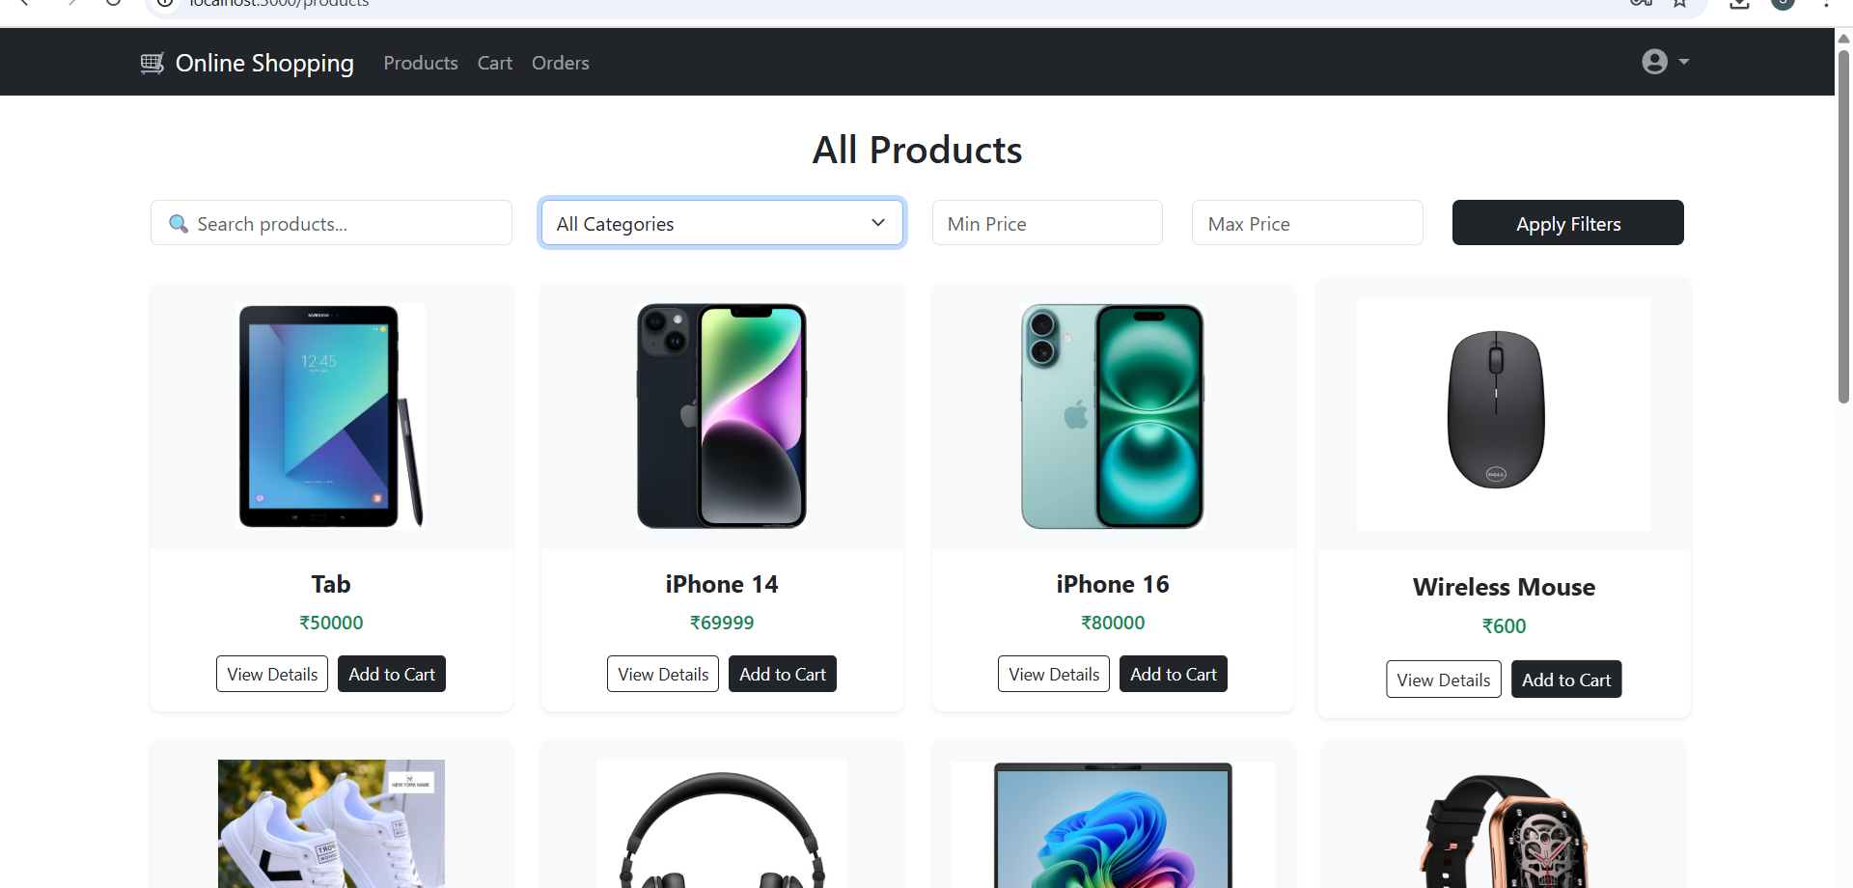
Cart Page
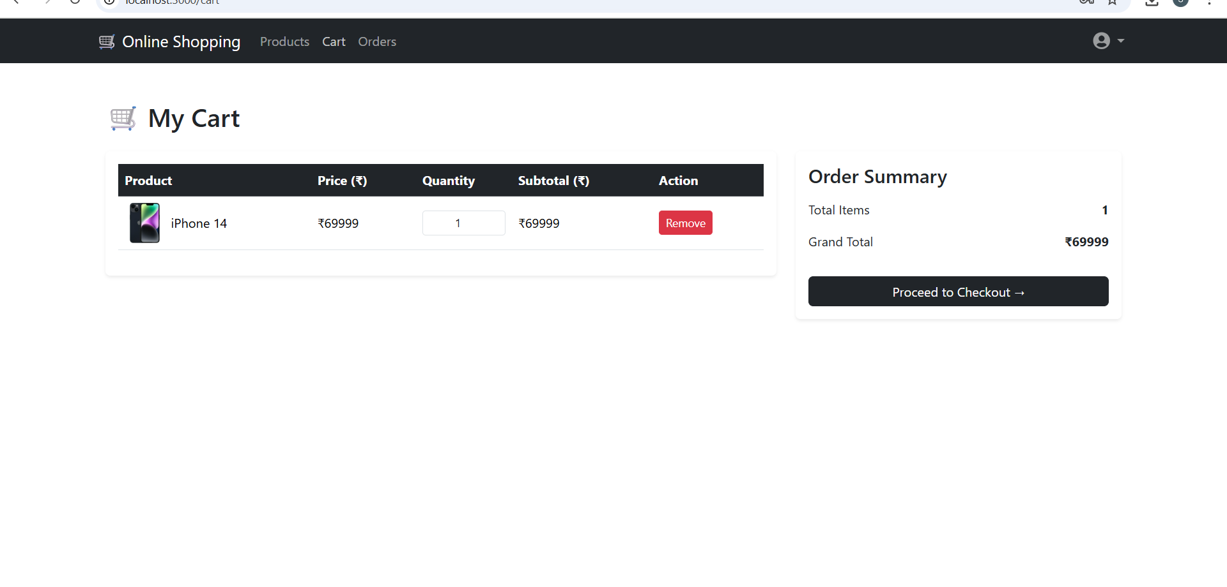
Order History Page
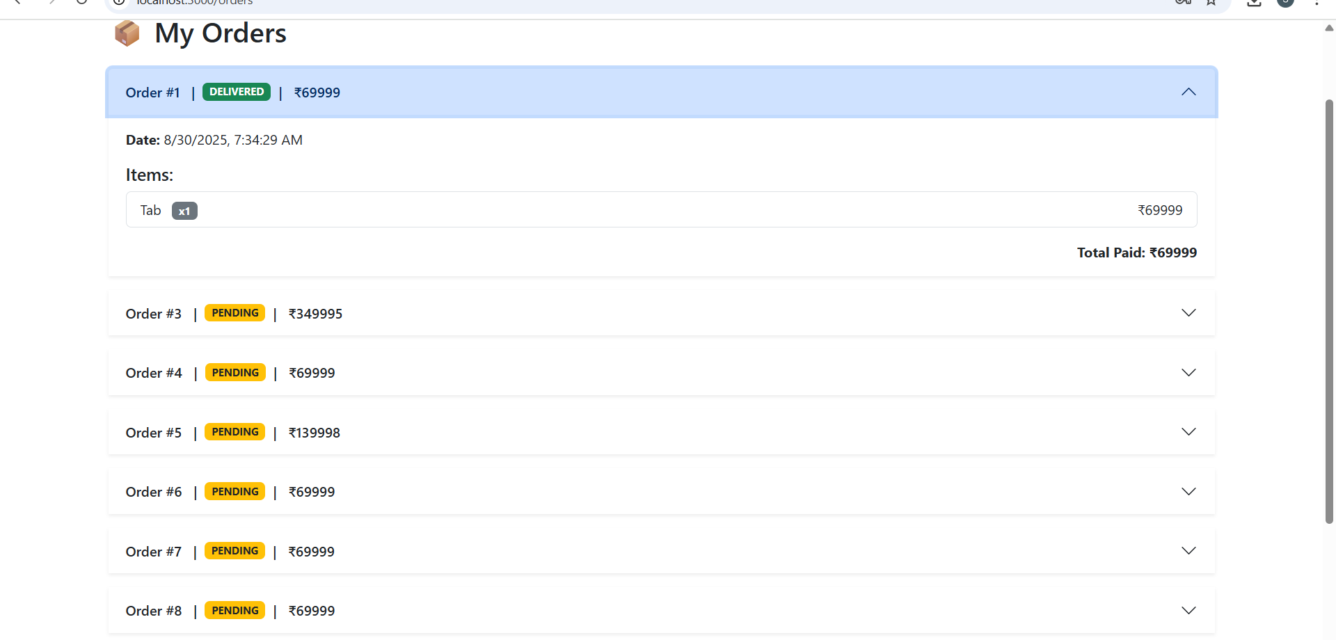
Checkout Page
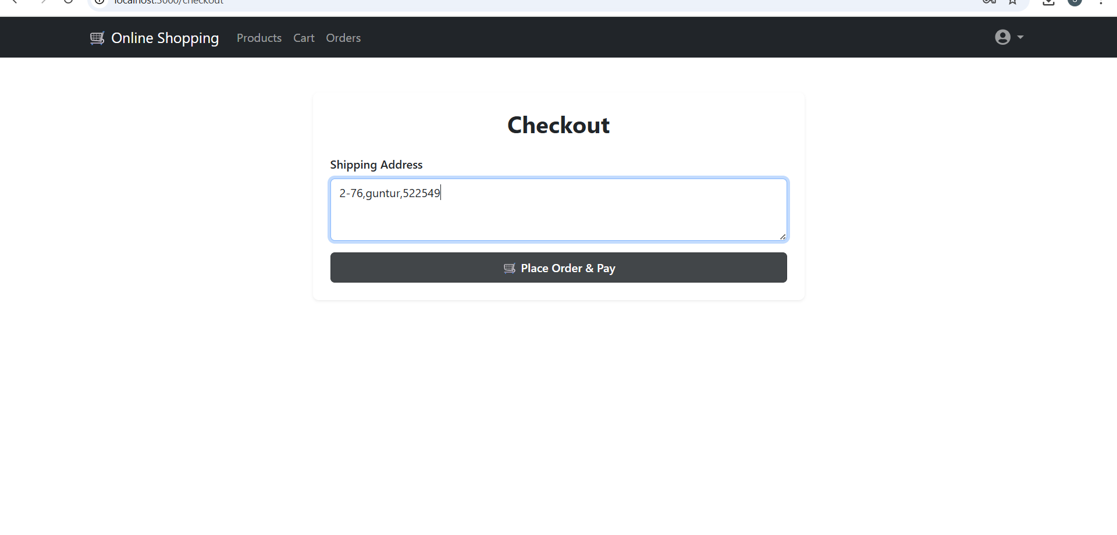
Admin Dashboard Overview
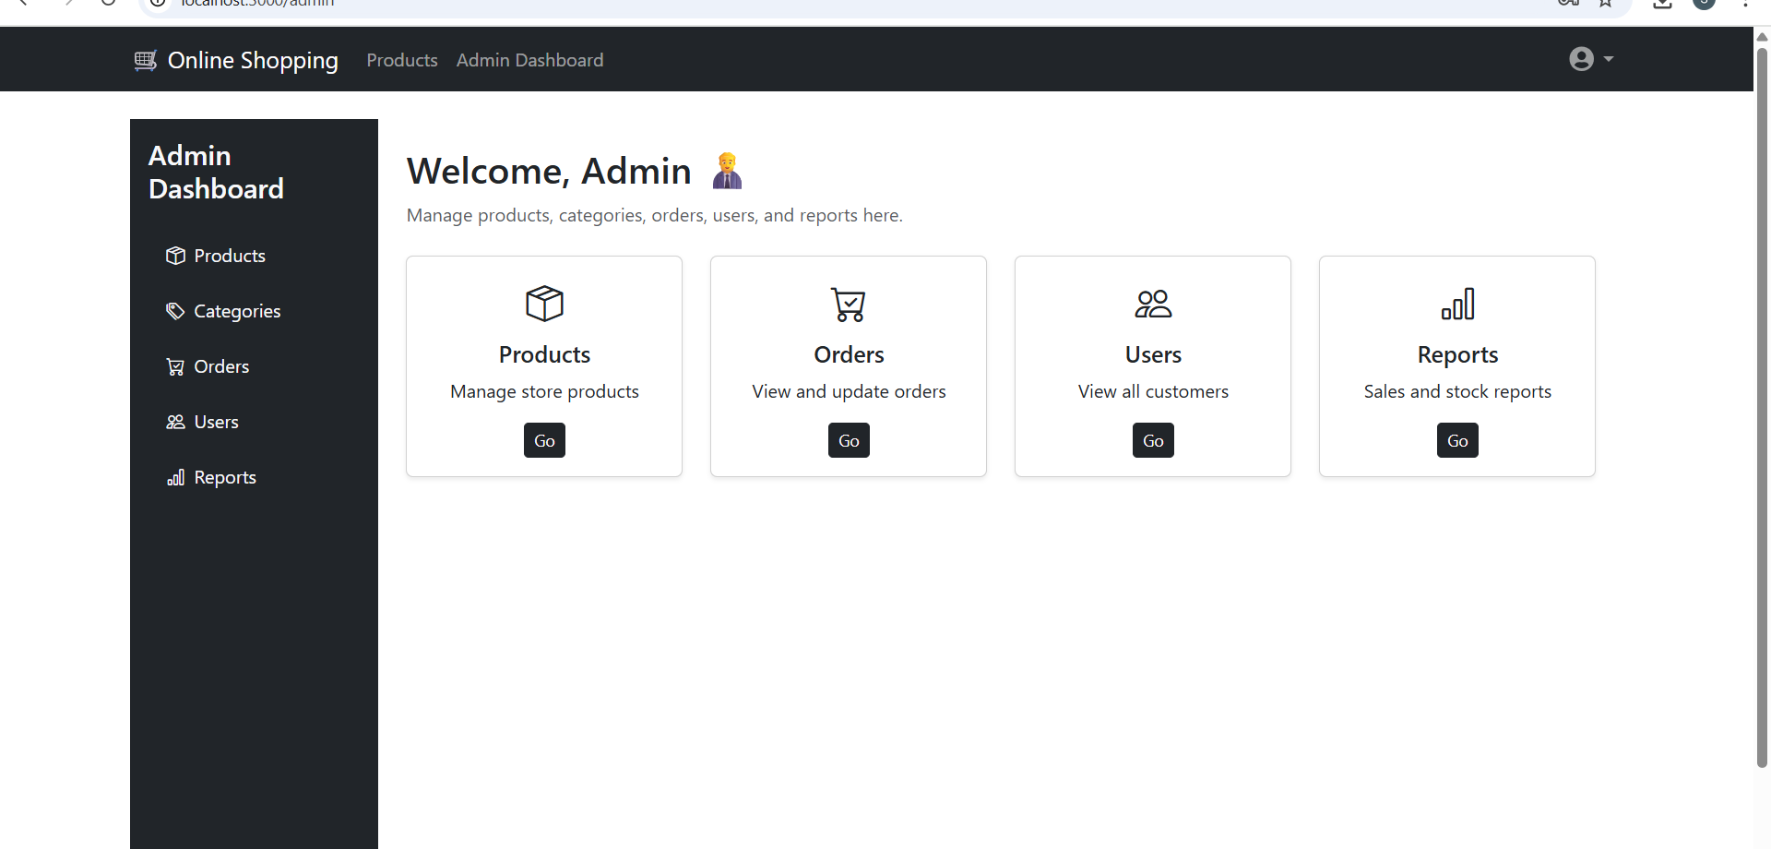

Admin Dashboard - Detailed Screenshots
Admin - Manage Products
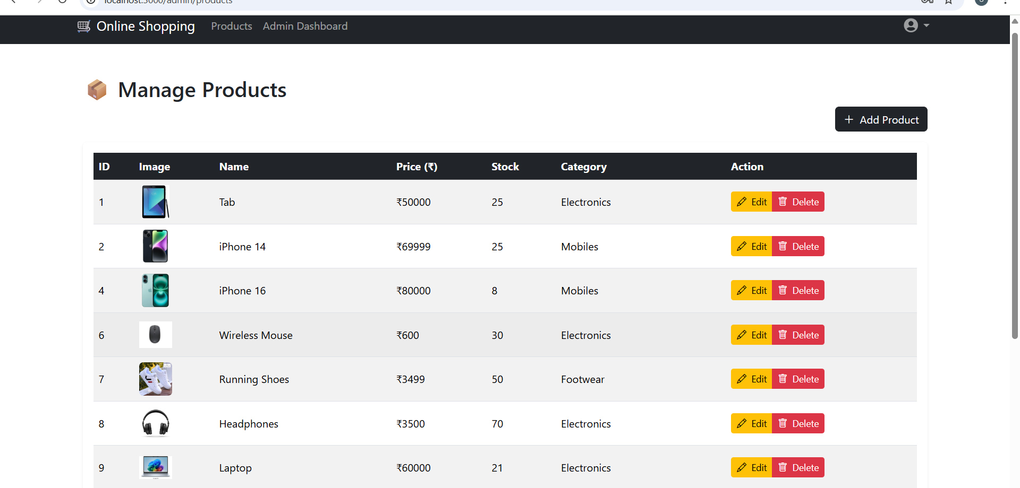
Admin - Manage Orders
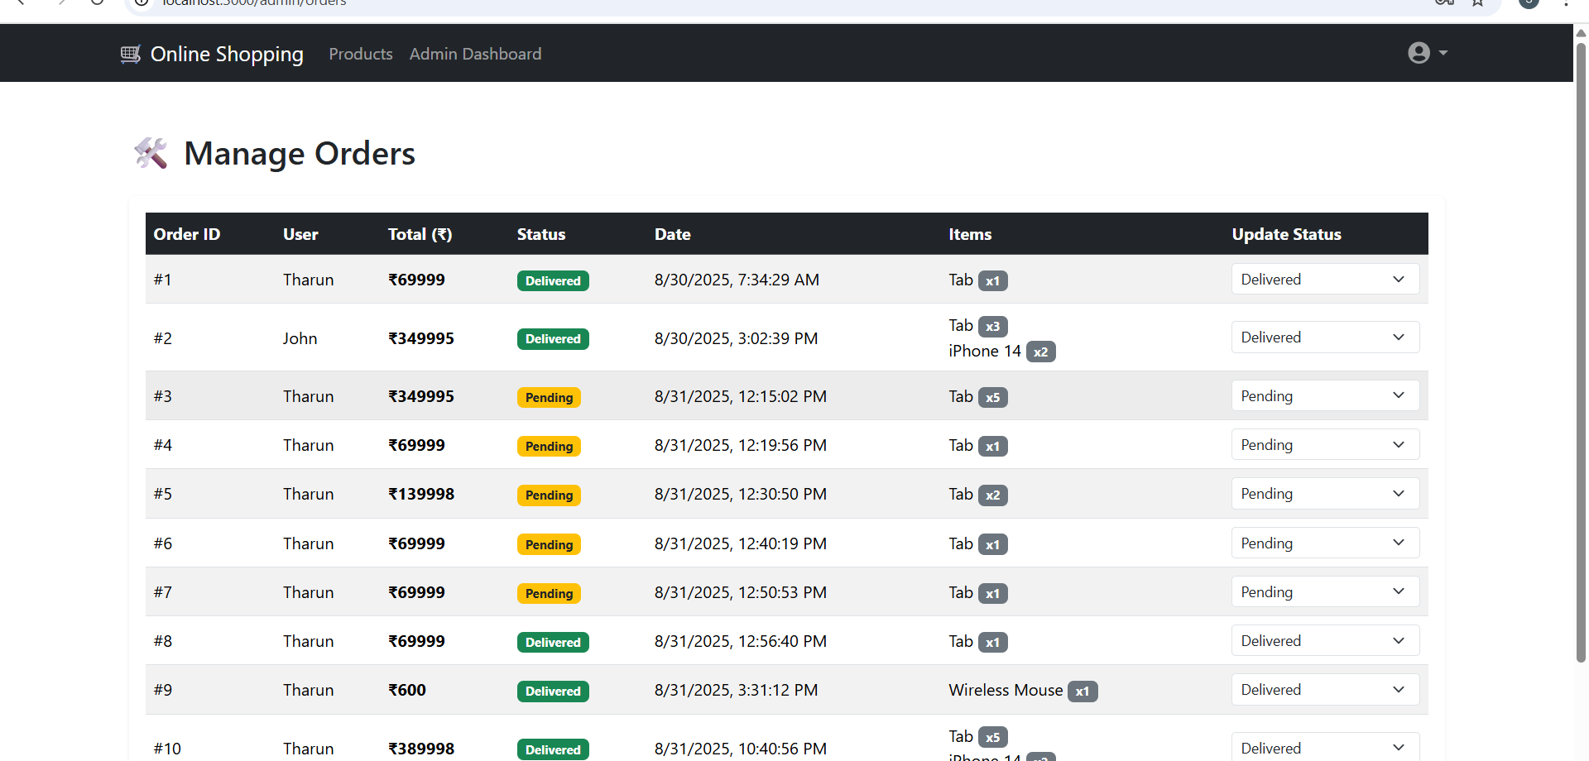
Admin - Manage Users
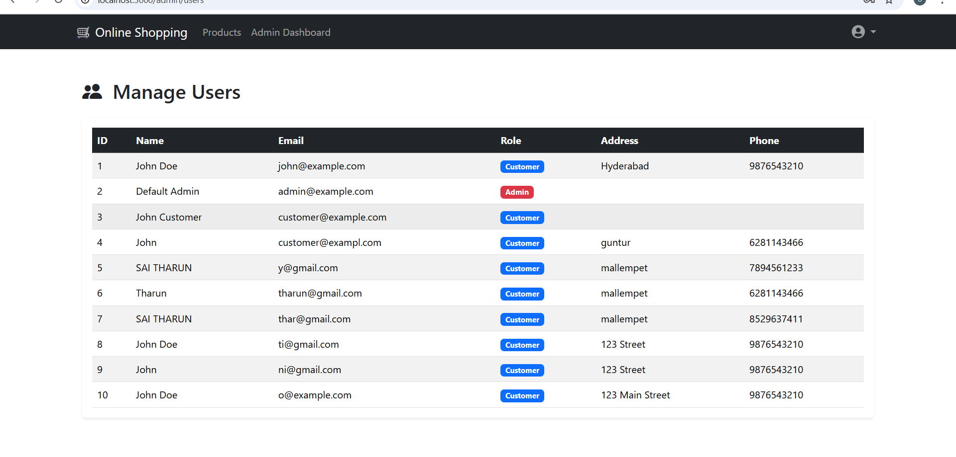
Admin - Reports
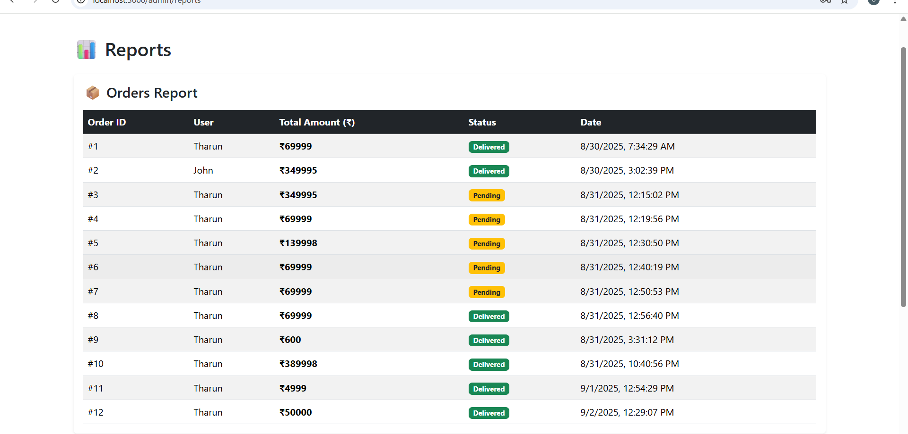

Backend Running - Screenshot
The screenshot below shows the Spring Boot application running successfully in Eclipse IDE.
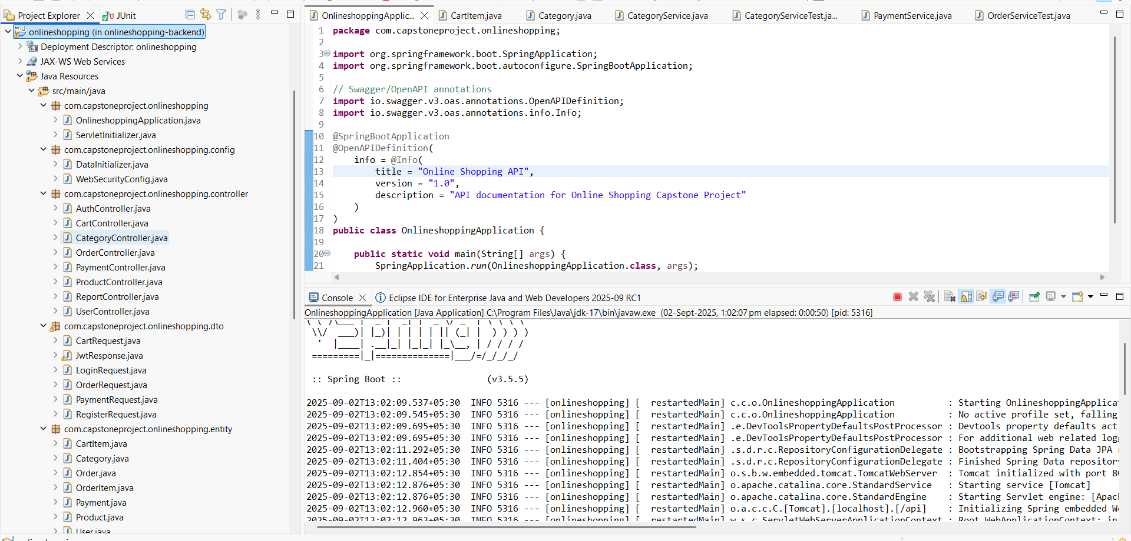

Swagger API Documentation - Screenshots
Swagger UI - Categories API
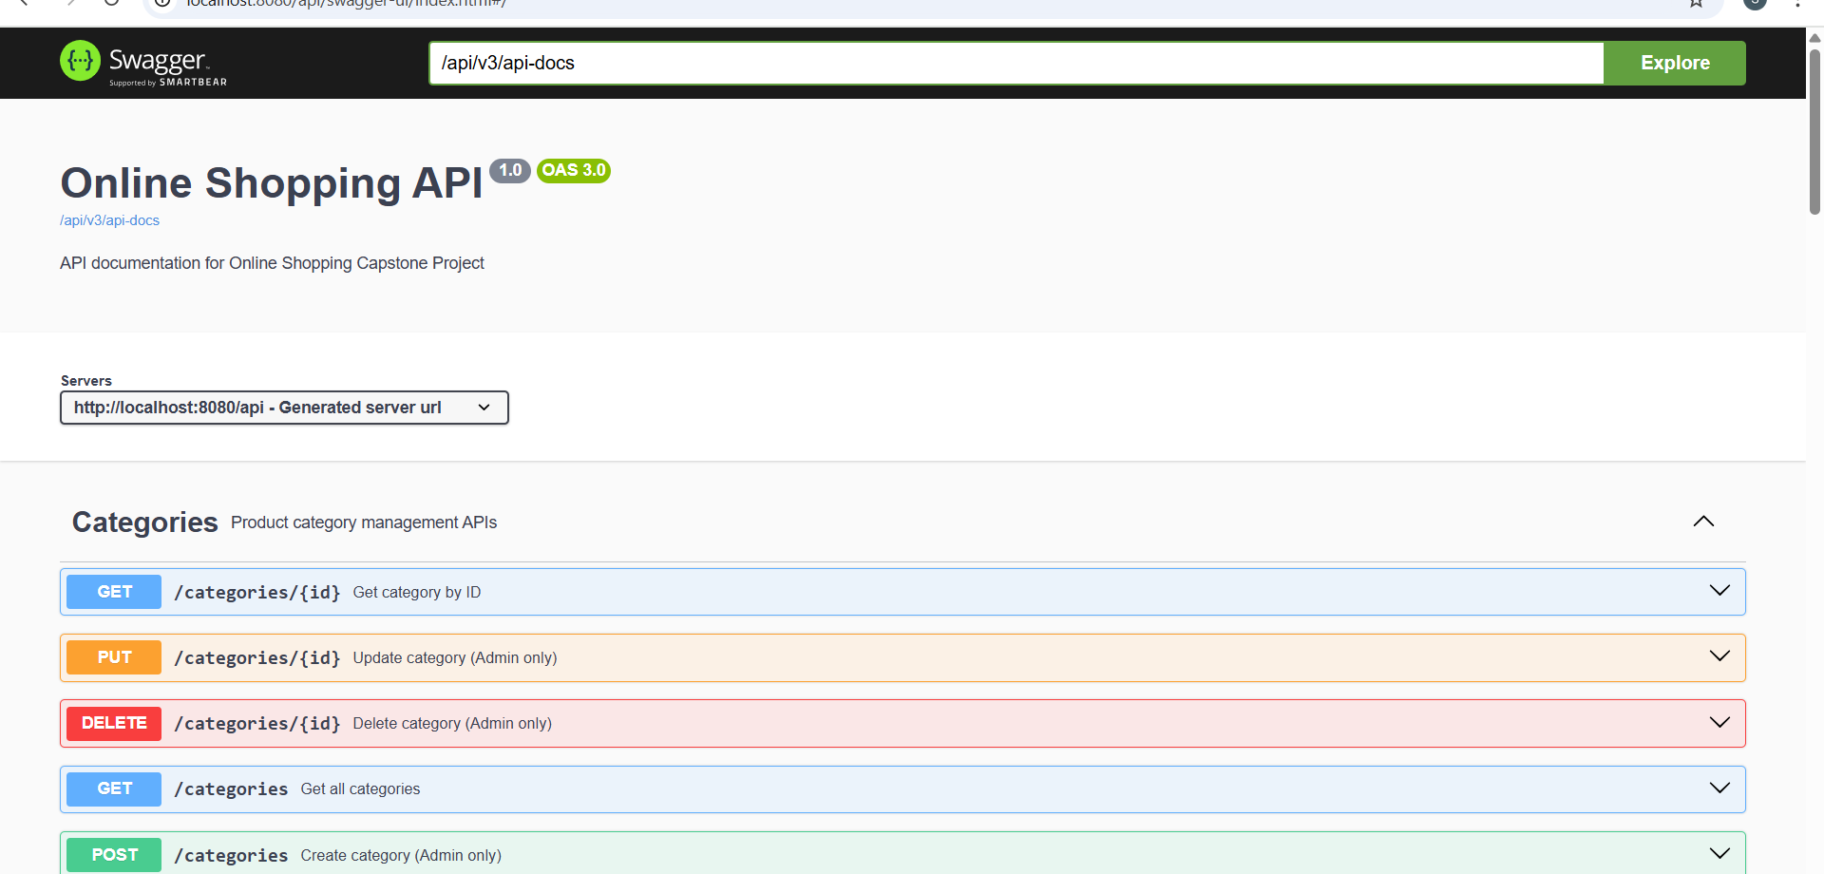
Swagger UI - Authentication & Products API
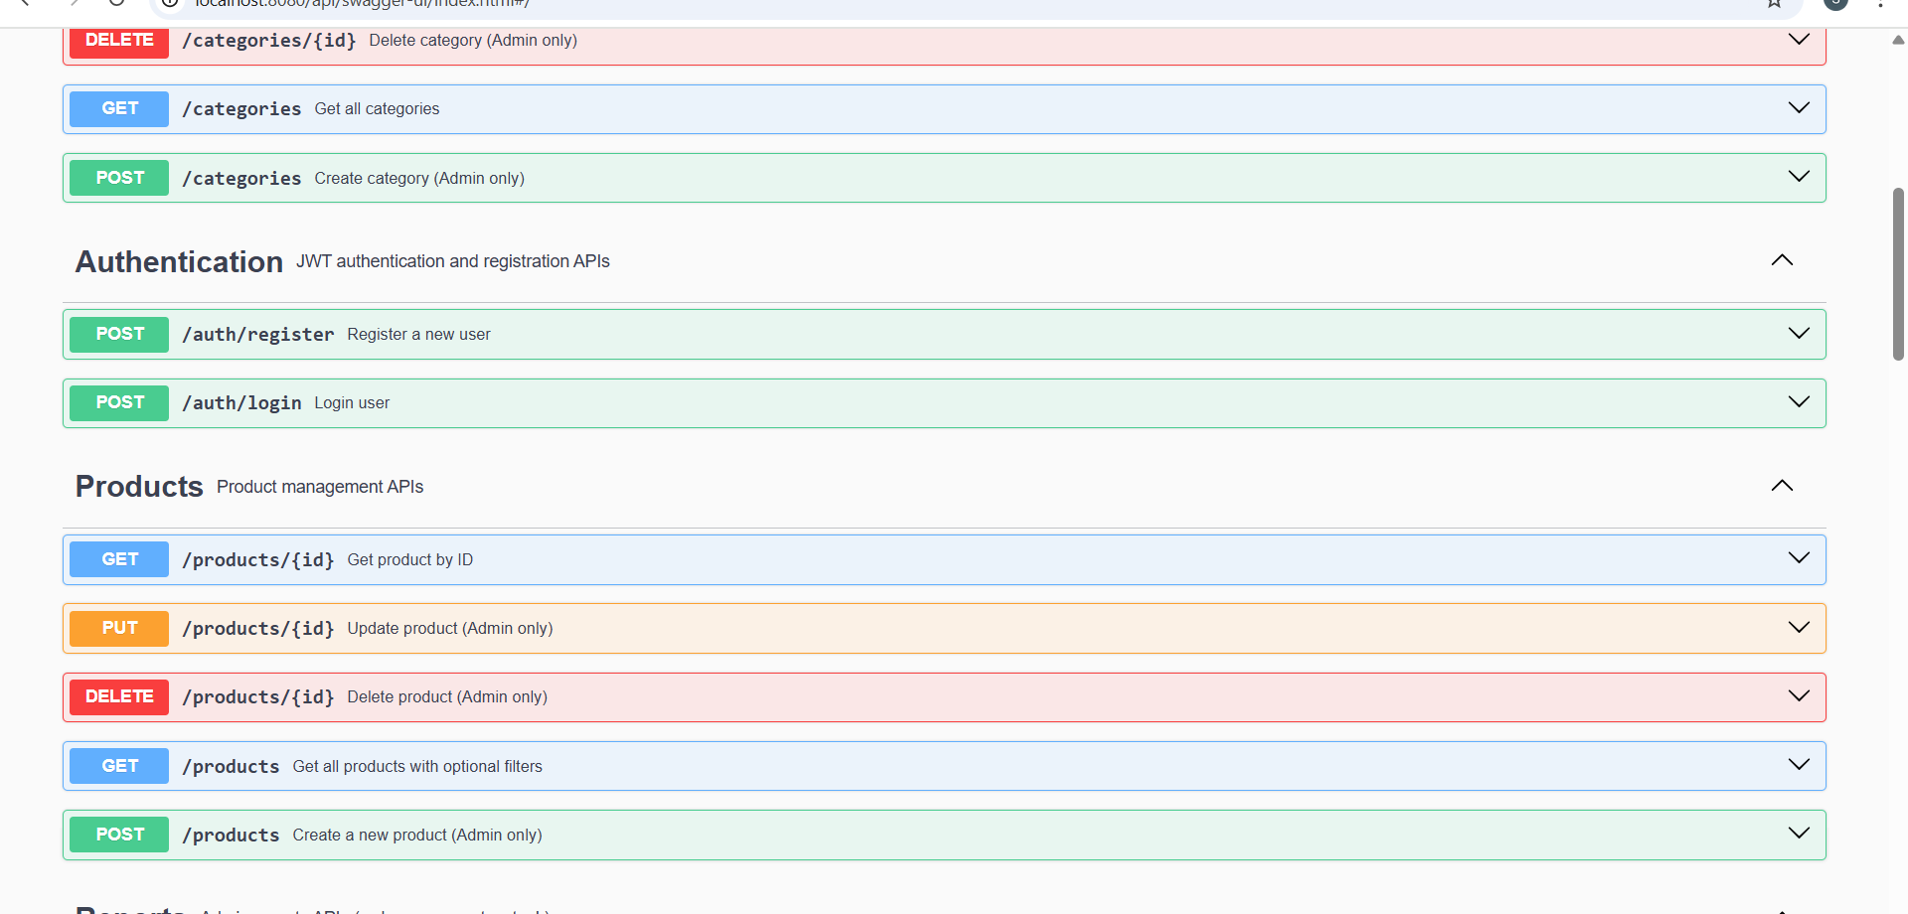
Swagger UI - Reports, Orders, and Payments API
